Nepal College of Information Technology
Unit Test
Spring 2012
Program : BE IT Time : 2 hrs
Semester : (II) FM : 70
Subject : Network Theory PM : 35

- Candidates are requested to give their answer as far as practicable in their own words.
- The figure in the margin indicates the full marks
- Attempt ALL question

1. a) In the figure, the switch is moved from position 1 to 2 at reference time t=0.Find the expression for current through the inductor for t>0. (7)
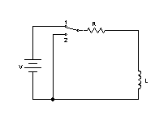
b) Fig shows a network which is assumed to be in the steady state before the operation of switch .Find the expression for the current when the switch is☹ 8)
i) Initially open but closed at t=0.
ii) Initially closed but opened at t=0.
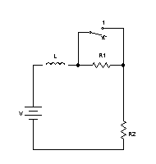
2. a) The circuit is initially relaxed .At t=0, the switch is closed .Find I1,I2, d2I1/dt2, d2I2/dt2. (8)
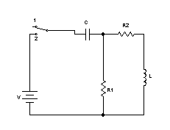
b) Find the expression for i(t) at t=0+. (7)
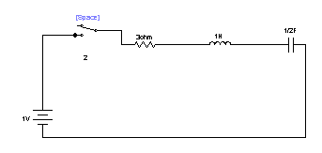
3. a) In the network ,switch is moved from a to b at t=0.Solve for I,di/dt,d2i/dt2 at t=0+ if R=1000 ohm, L=1H,C=0.1 micro farad and V=100v. (8)
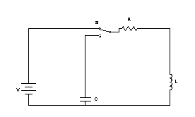
b) the has its switch opened at t=0,solve for V,dV/dt and d2V/dt2 at t=0+ if Is=1A,R=100 ohm, L=1H. (7)
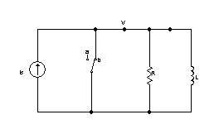
4. a) Find the expression for the current through inductor at t=0+. (8)
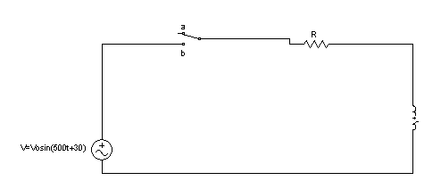
b) Solve the equation I’’(t)+10I’(t)+25I(t)=0 with the initial condition i(0+)=2 and di(0+)/dt=0. (7)
5. Write short notes on (Any two) (5*2)
i. Transient and steady states.
ii. Laplace transform and its advantages over classical method of problem solving.
iii. Initial conditions .

